CLOUD COMPUTING
SUBMITTED BY: ARMEEN ABID (BSE-011)
SUBMITTED TO: ENGR.MUHAMMAD SHOAIB
LAB 08
TASK 1:

Create an AWS account and enable UAE

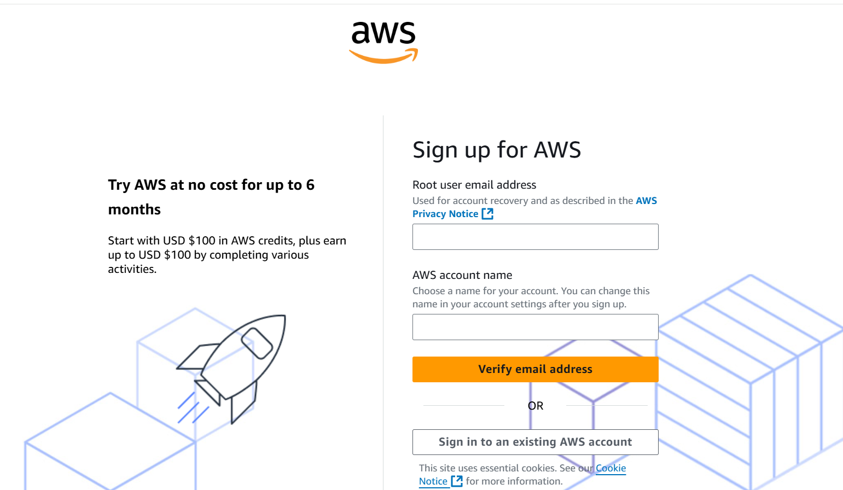
Complete registration, fill contact, billing (credit card) and phone details, complete verification.
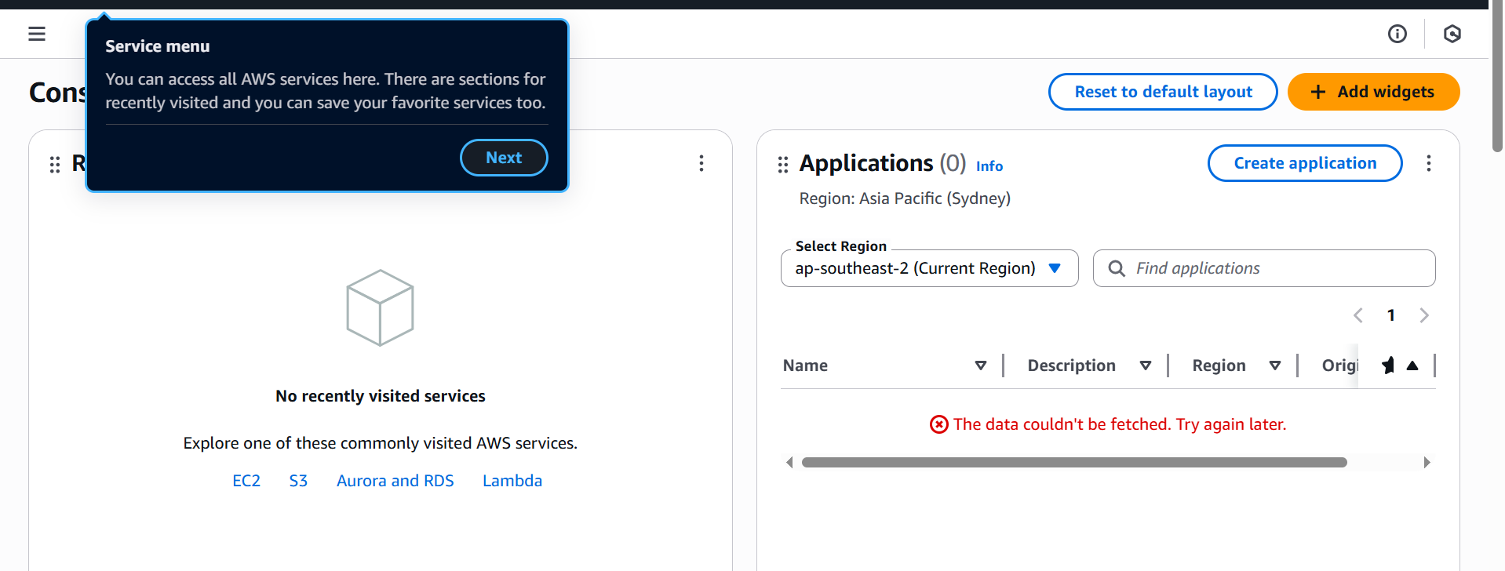

Sign in as the root user
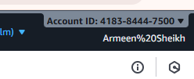

From the Console, open the region selector and enable UAE (me-central-1), then switch to me-central-1.
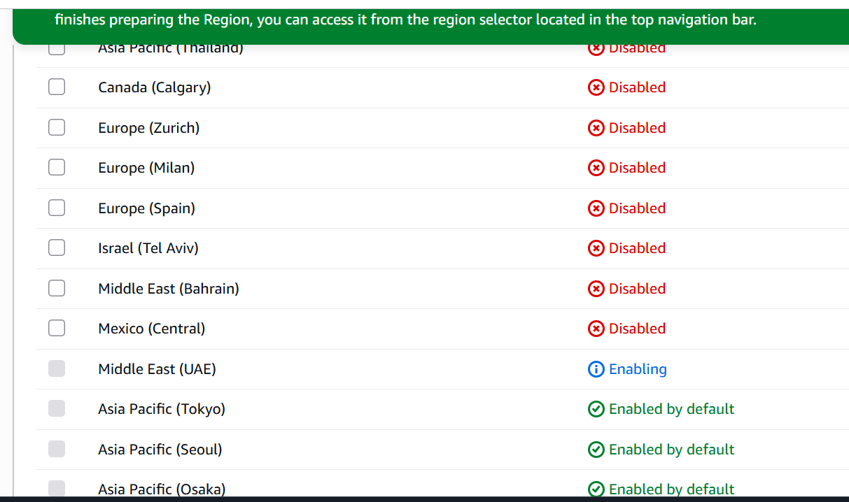

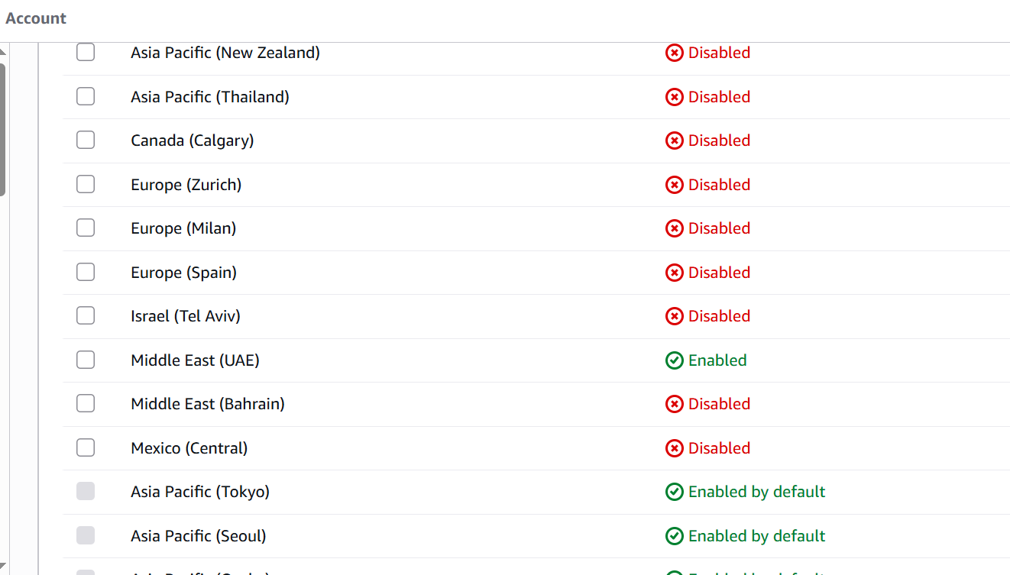
TASK 2:
Create IAM Admin and Lab8User with console access
Open IAM via Console search
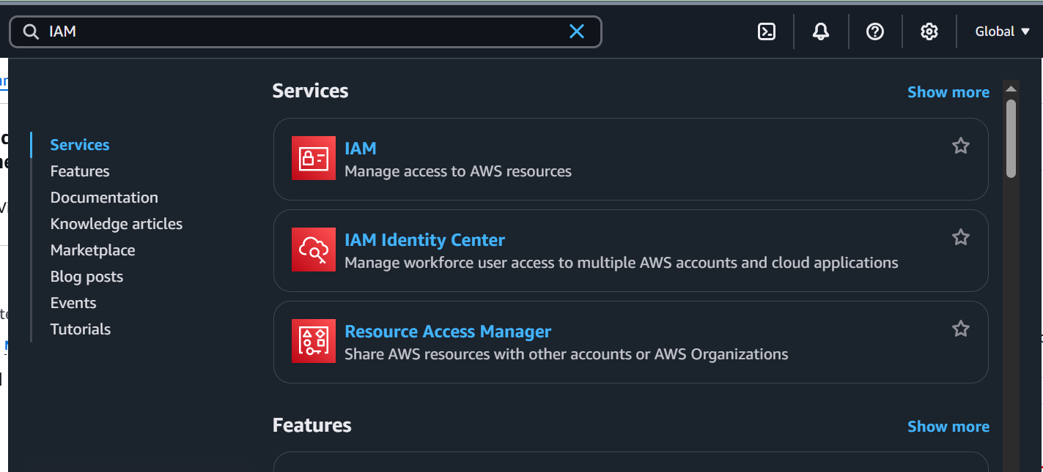
Create the Admin user
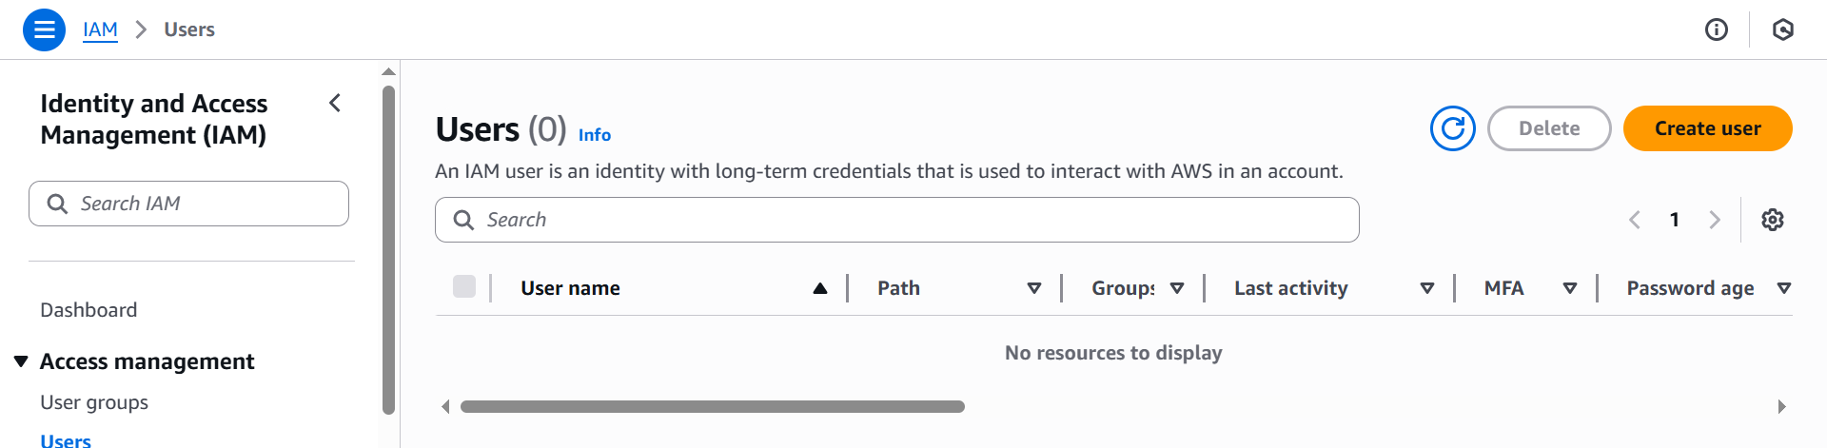

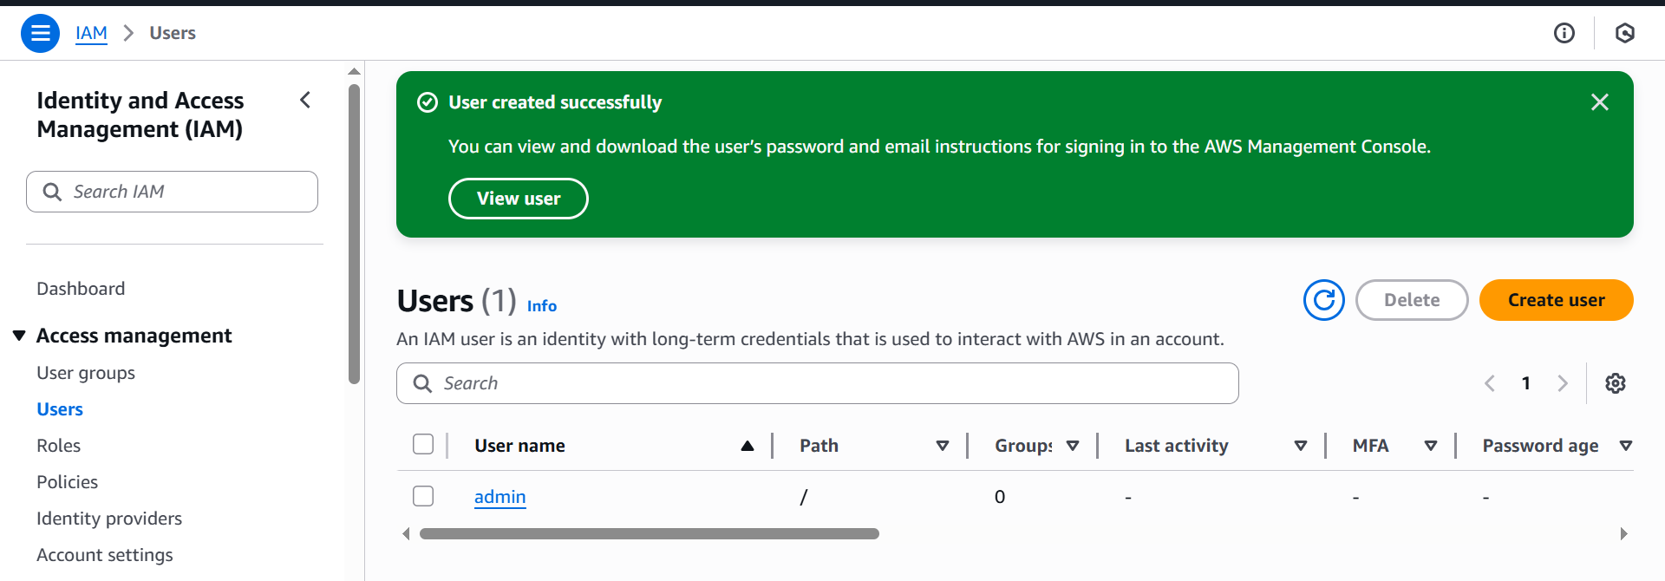

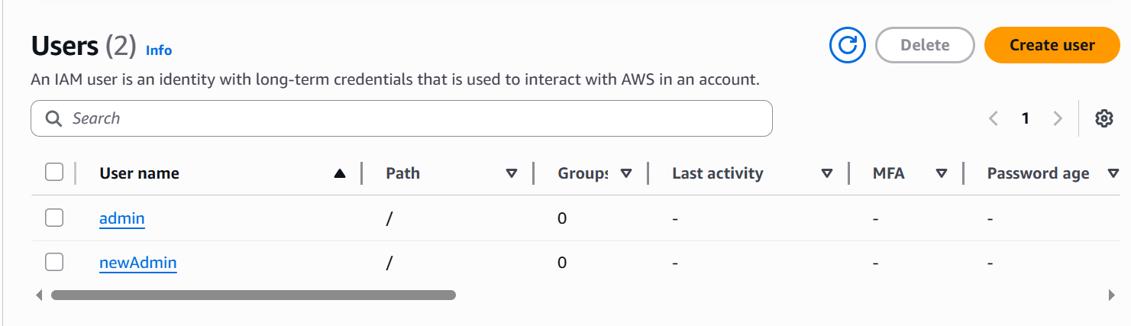
Download the Admin .csv and show its presence on your Windows host (do not display the password text):
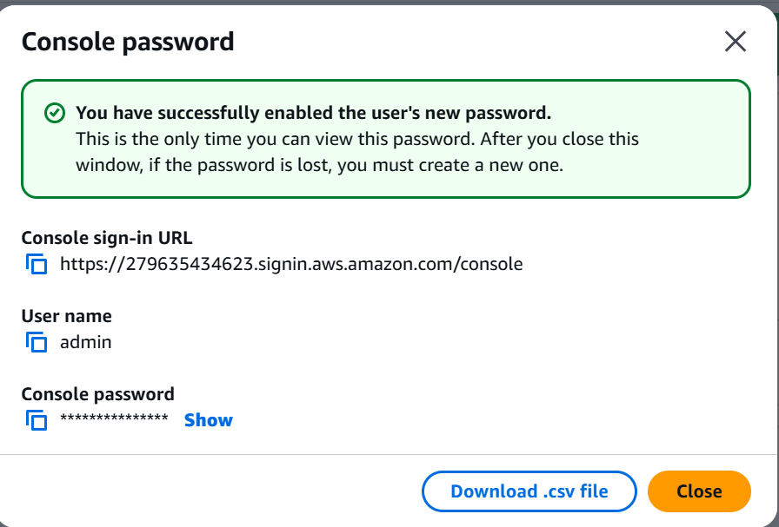
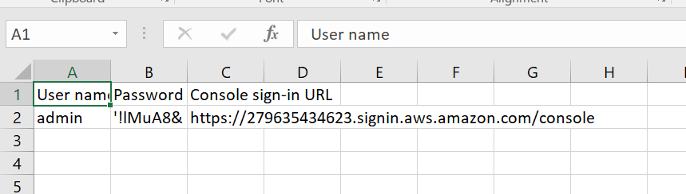
Sign out of root, then sign in using the Admin account
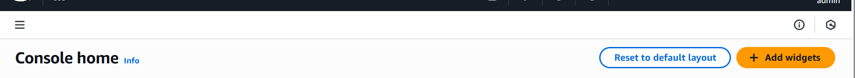

While logged in as Admin, create Lab8User
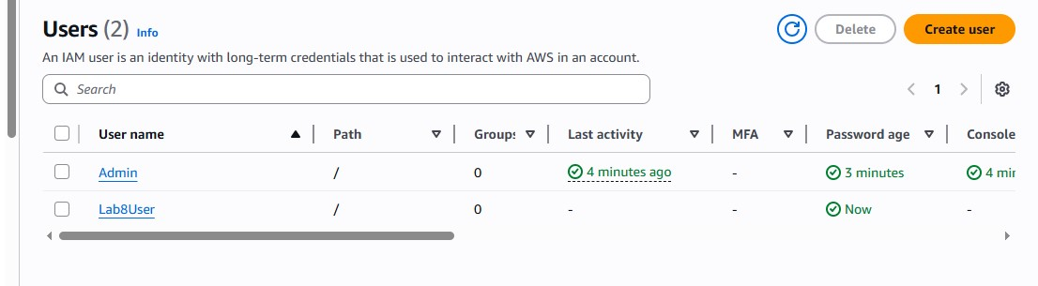
Download/save the Lab8User CSV on your Windows host (do not show password).
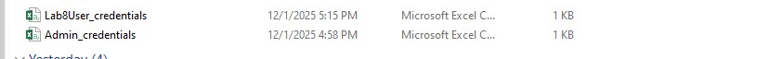
Save screenshot as: task2_lab8user_csv_saved.png — File Explorer showing the Lab8User CSV filename (cropped to exclude sensitive content).
Logout Admin and login as Lab8User (use the Lab8User signin URL and credentials).
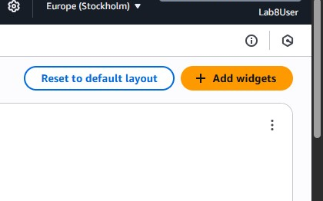
Task 2 summary:
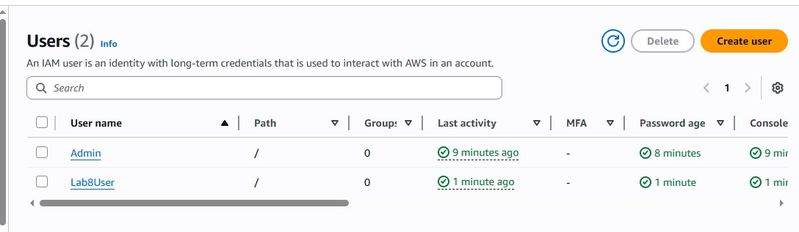

TASK 3:
Inspect VPC resources
Open VPC console
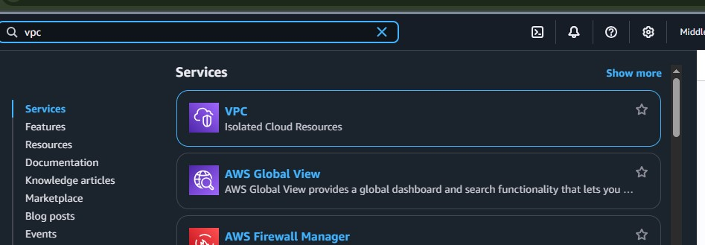
View VPCs list
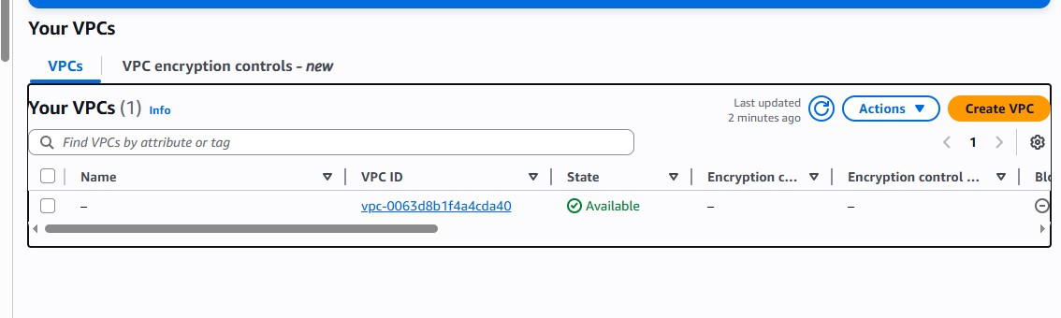
View Subnets list.
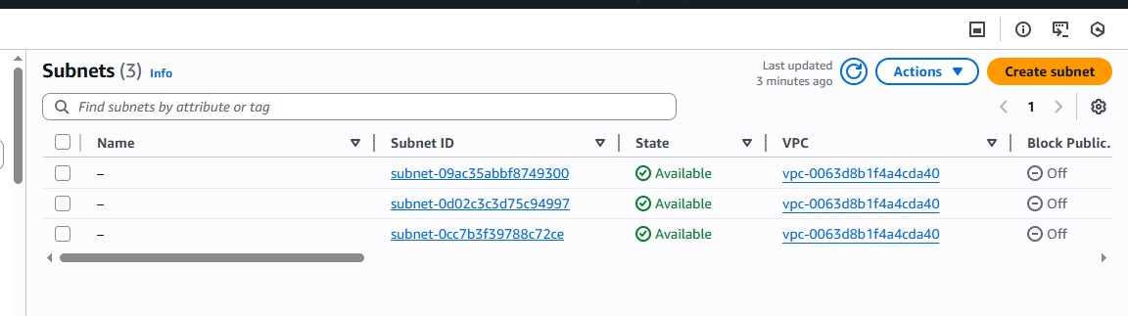
View Route Tables list.
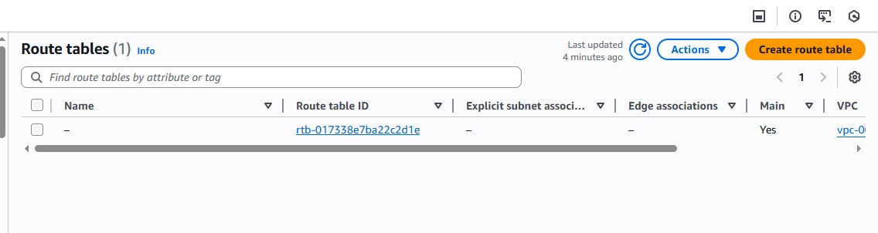
View Network ACLs list
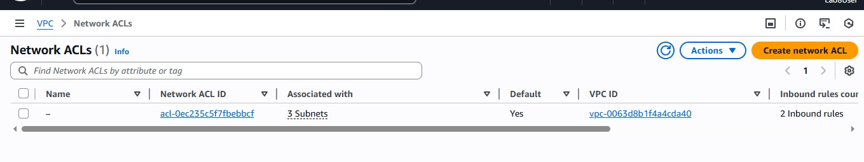
Task 3 summary:
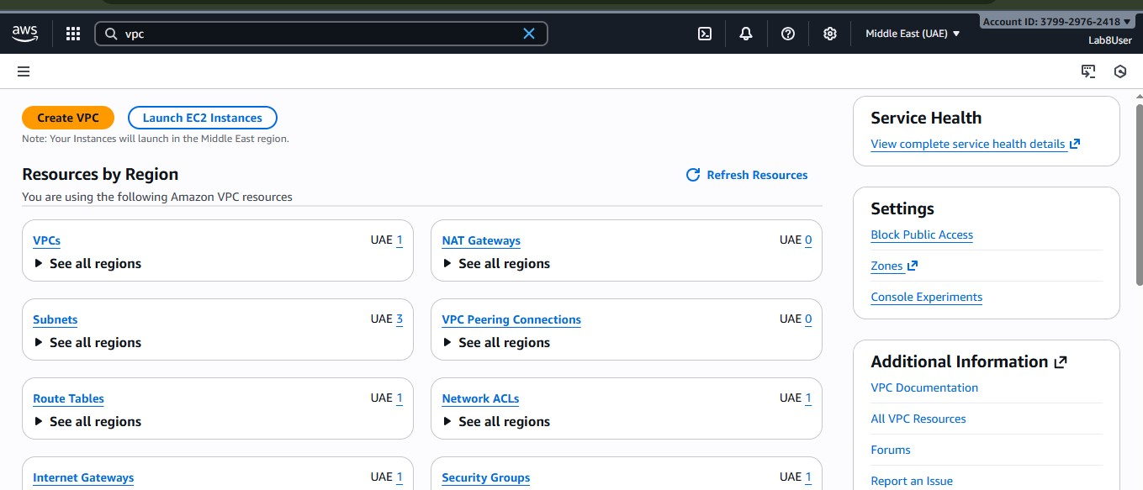

TASK 4:
Launch EC2, SSH, install Docker & Docker Compose, deploy Gitea
Open EC2 Console
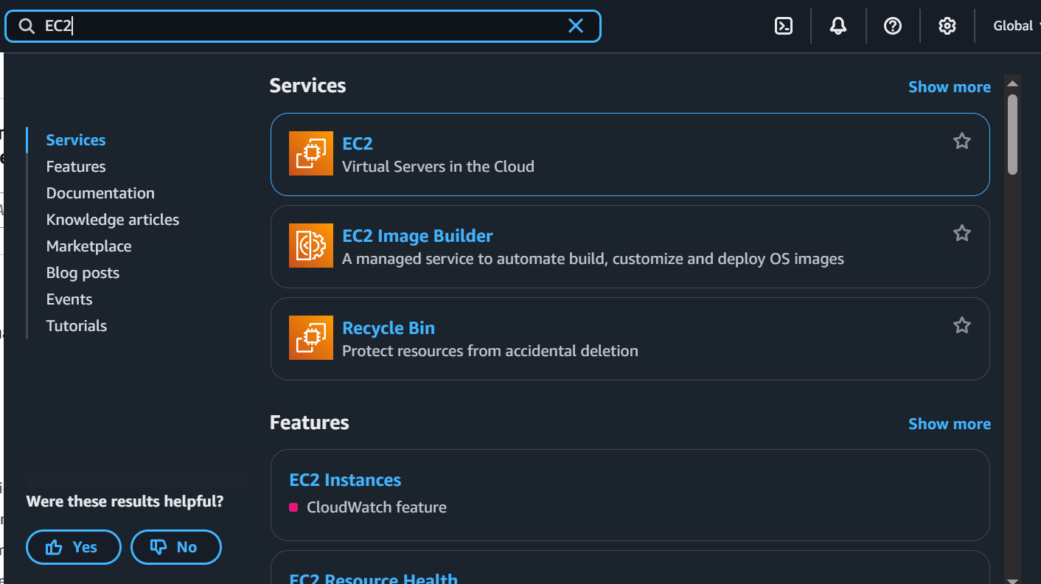
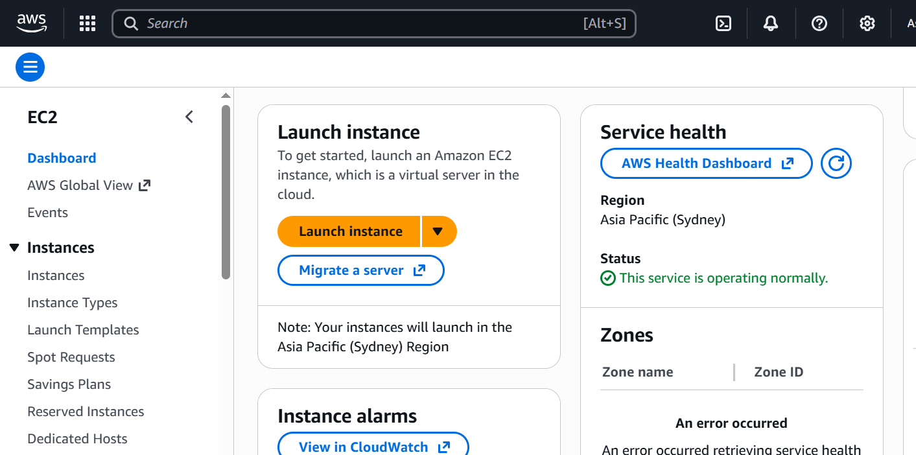
Instance Launch configuration
AMI: Amazon Linux 2
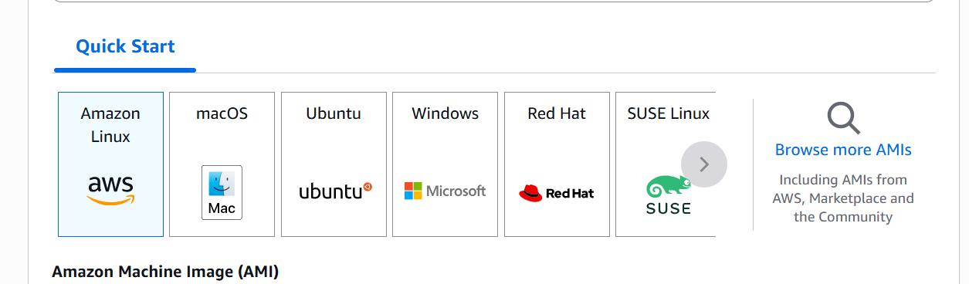
Instance type: t2.micro
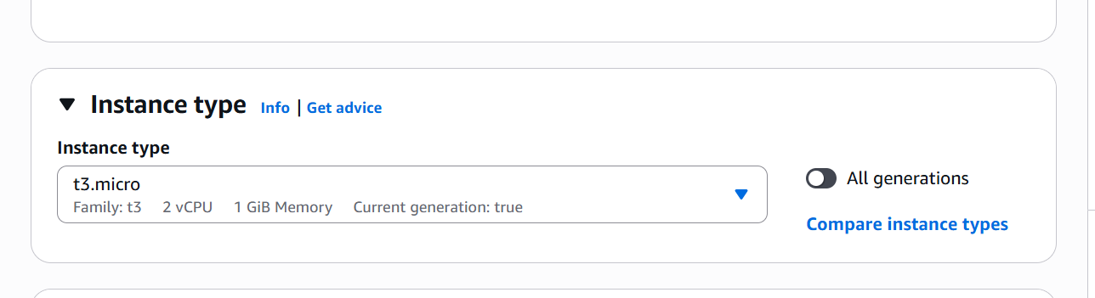
Security group: Create Lab8SecurityGroup with SSH from My IP
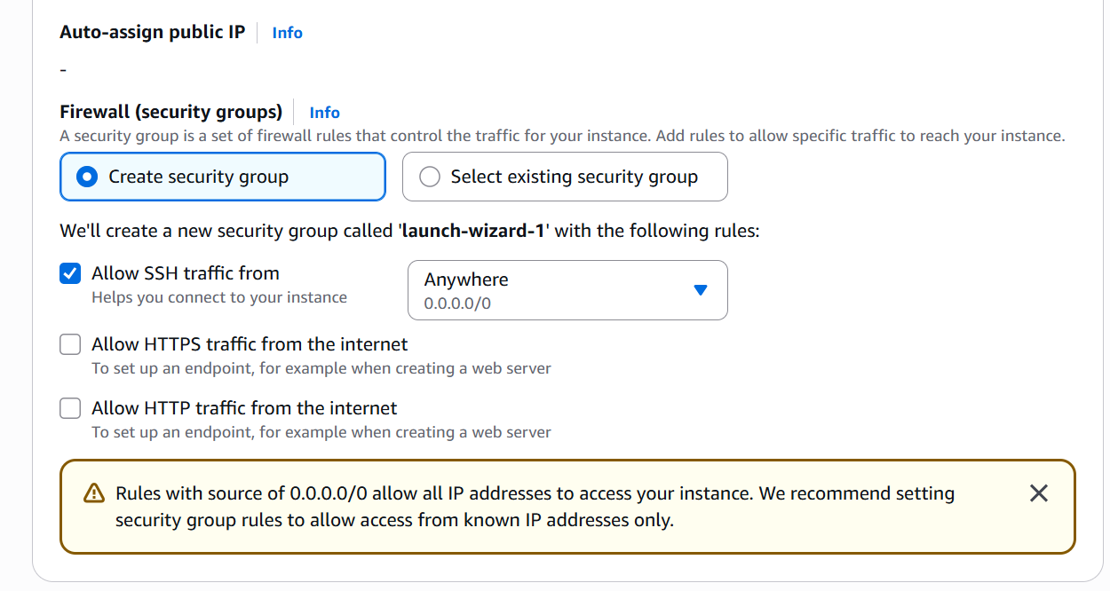
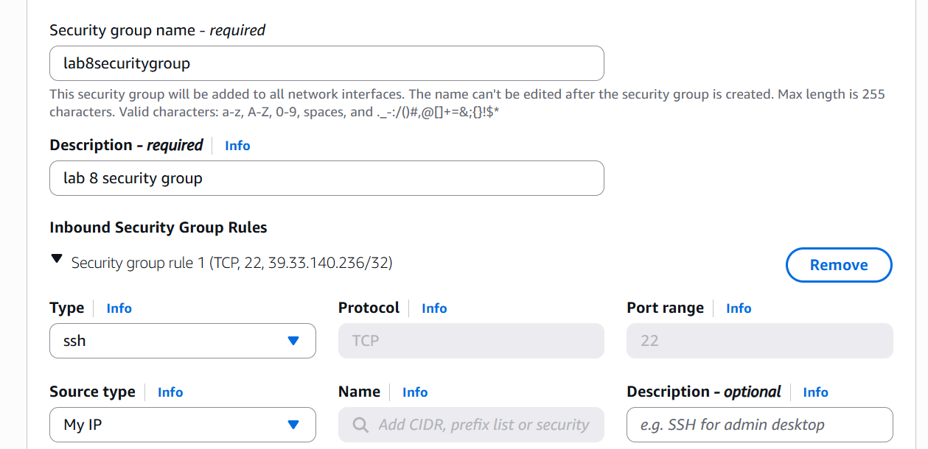
Storage: default
Key pair: Create Lab8Key (ED25519, .pem) and download the .pem file to your Windows host
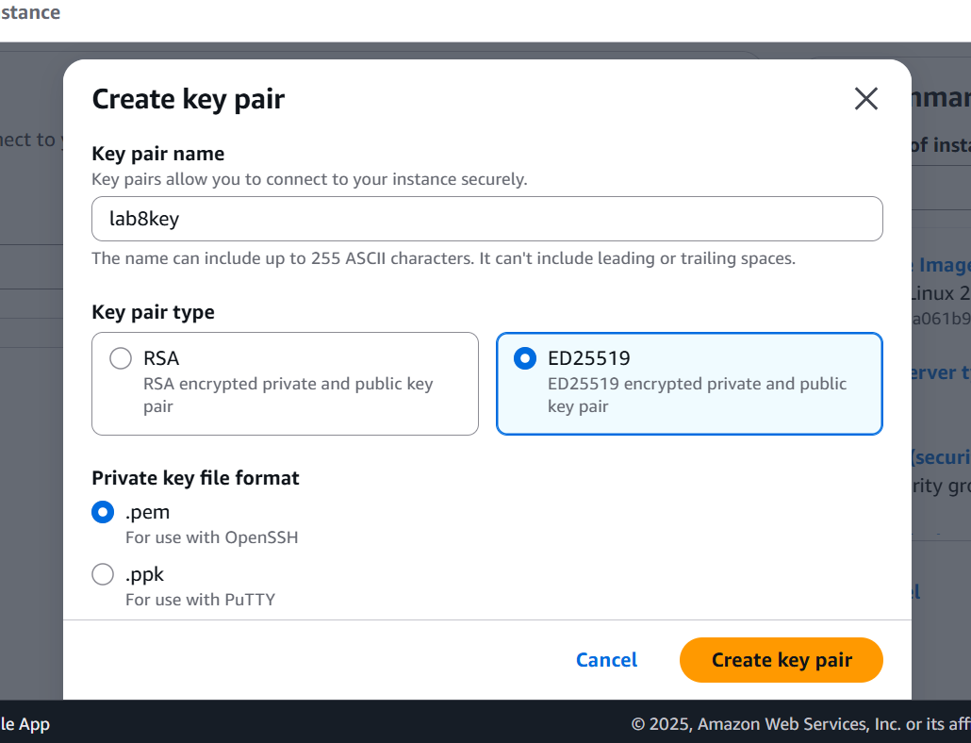
Capture the final review page and the key download prompt:
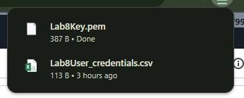
After launch, EC2 Instances list showing Lab8Machine in "running" state and public IPv4 visible.
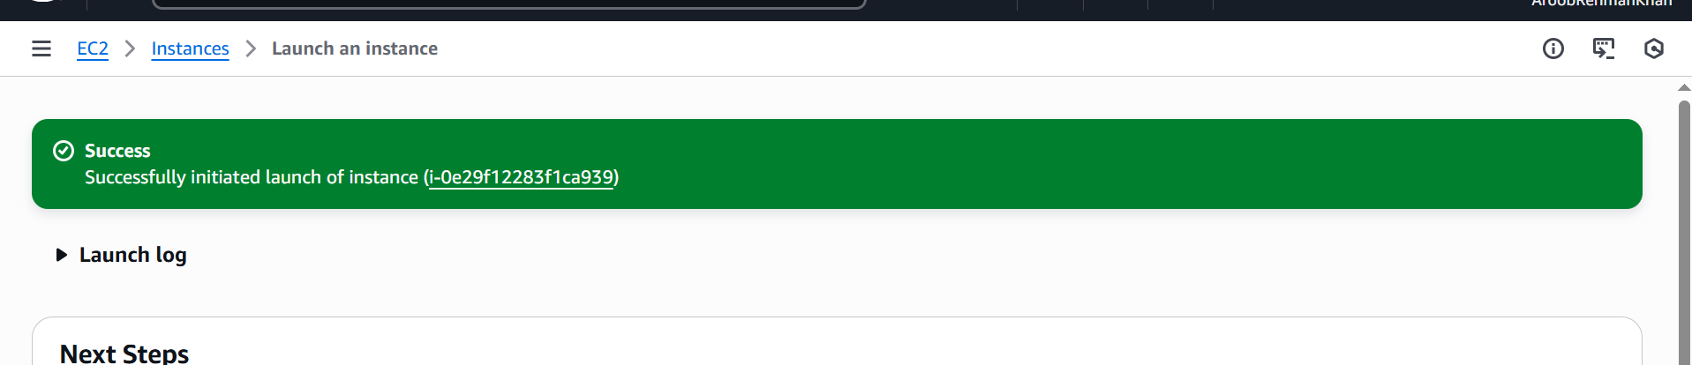

On Windows host, run SSH using the downloaded .pem (PowerShell/Git Bash/Windows Terminal):
Capture the SSH command and successful shell prompt on the EC2 instance
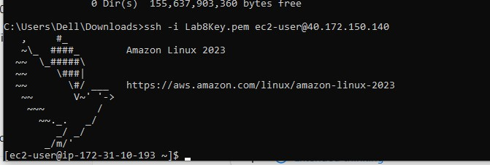
Run the install commands on the EC2 shell:
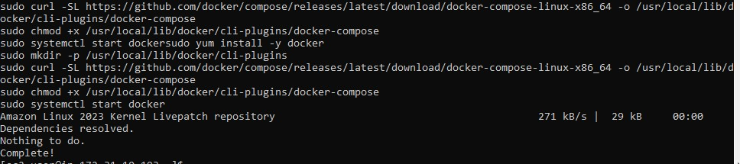
Capture the terminal showing these commands run and successful outputs:
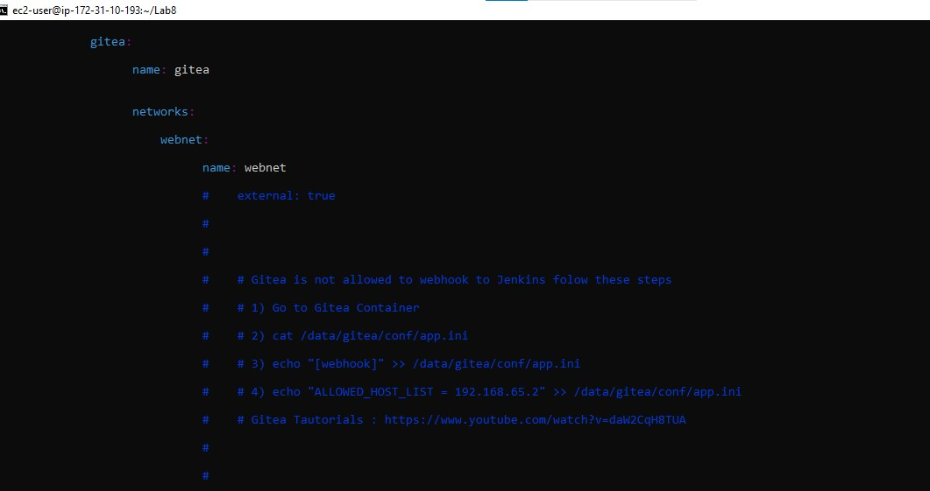
Create/edit compose.yaml on the EC2 instance (sudo vim compose.yaml) and paste content from the repo: Gitea . While pasting, capture the editor content:
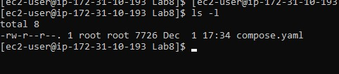
Add ec2-user to docker group, show groups before re-login, exit and reconnect, show groups after reconnect
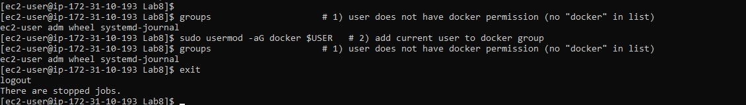

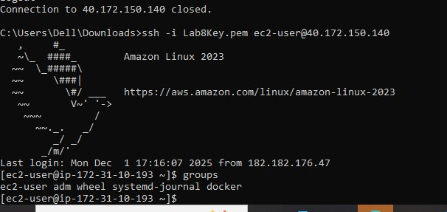
Run docker compose up -d from the directory with compose.yaml:
Edit the security group Lab8SecurityGroup inbound rules in the EC2 console: add Custom TCP rule port 3000 source 0.0.0.0/0 and save. Capture the inbound rules after saving:
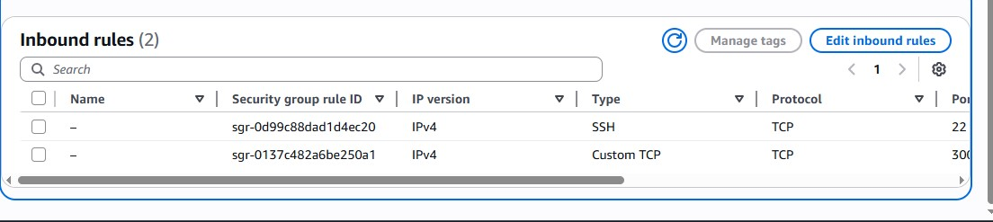
From your Windows browser navigate to: http://Public-IP:3000 — capture the Gitea setup/install page:
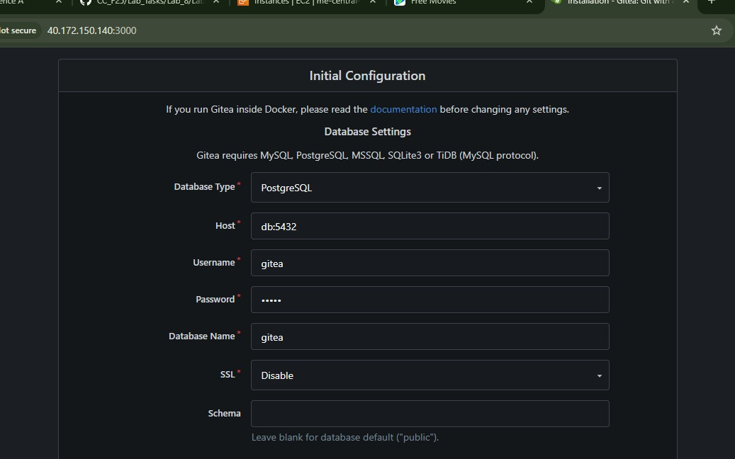

Cleanup — Remove resources to avoid charges
After verification, terminate and delete everything you created. Capture screenshots immediately after each cleanup step.
Cleanup steps and required screenshots:
- Terminate the EC2 instance Lab8Machine.
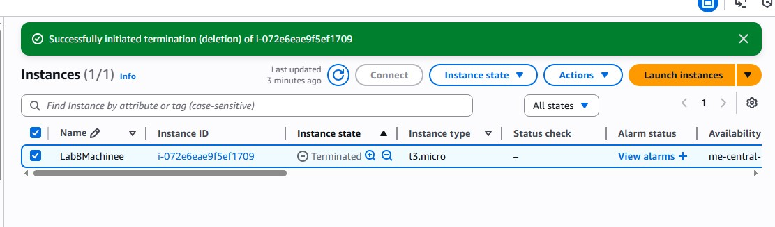
- Delete security group Lab8SecurityGroup and key pair Lab8Key from the EC2 console (after instances terminated).
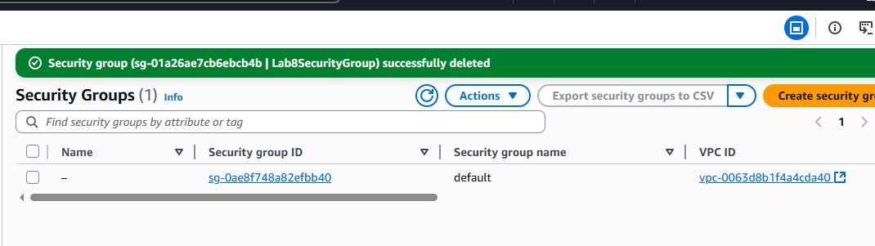

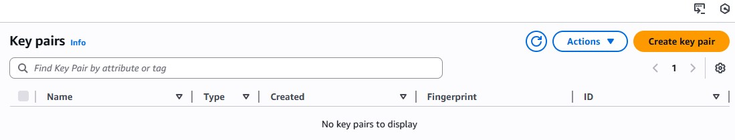

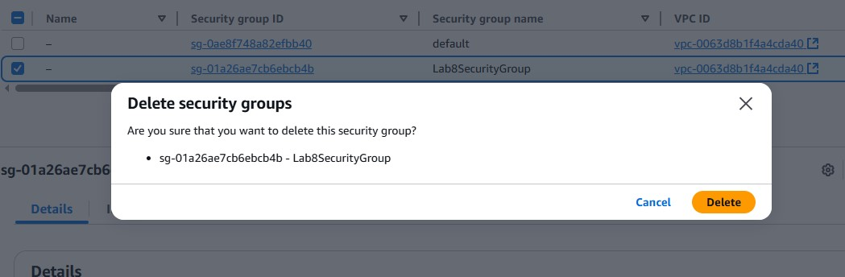

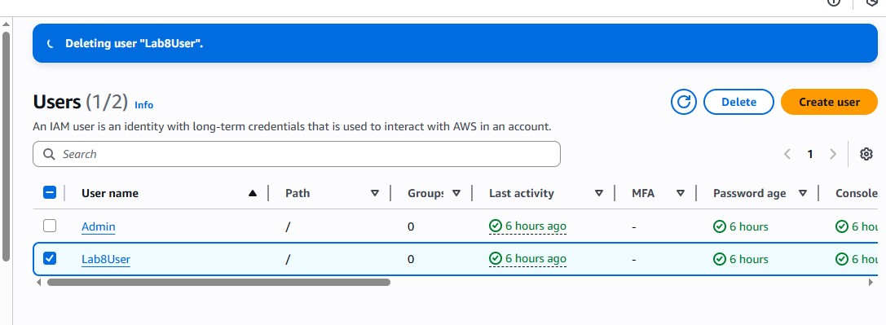
- Final cleanup summary (show billing or resource groups with no active resources
